SDA ASSIGNMENT 2 24K-1033 BCS-4B

Q1

@startuml
actor Emily
participant "Mountain Retreats" as Platform
database "Calendar System" as Calendar
boundary "Payment Gateway" as Payment
actor "Jack (Owner)" as Jack

Emily -> Platform : register(details)
Platform --> Emily : confirmRegistration

Emily -> Platform : searchProperties(location, dates)
Platform --> Emily : showListings(Cozy Cabin)

Emily -> Platform : requestDetails(Cozy Cabin)
Platform -> Calendar : checkAvailability(dates)
Calendar --> Platform : isAvailable
Platform --> Emily : confirmAvailability

Emily -> Platform : createReservation()
Platform --> Emily : bookingID

Emily -> Payment : submitPayment(details)
Payment --> Emily : paymentSuccess

Platform -> Jack : notifyReview(feedback)
@enduml

OUTPUT

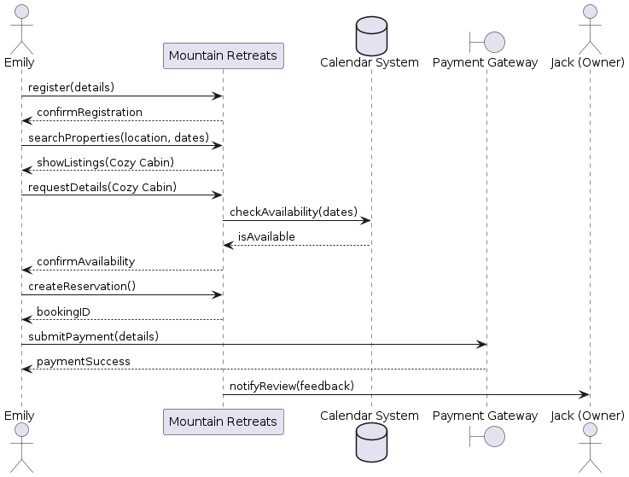

Q2

@startuml
actor User
participant System
database Database

== Scenario 1: Login ==
User -> System: loginRequest
System -> Database: queryCredentials
Database --> System: credentials
alt valid
System --> User: successMessage
else invalid
System --> User: failureMessage
end

== Scenario 2: Update ==
User -> System: initiateUpdate
System -> Database: validateUpdate
Database --> System: validationResult
System -> Database: updateRecord
Database --> System: confirmUpdate
System --> User: finalSuccess
@enduml

OUTPUT

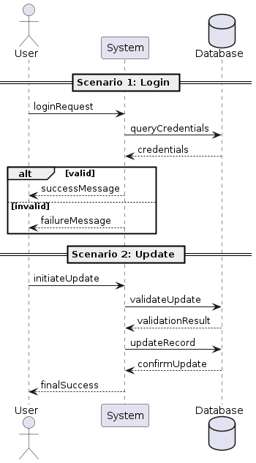

Q3

@startuml
|Customer Service Clerk|
start
:Enter customer information;
|System|
:Find policy and display details;
|Customer Service Clerk|
:Verify policy;
if (Policy is current?) then (no)
:Request payment/Collect info;
else (yes)
endif

|Customer Service Clerk|
:Enter vehicle identification;
|System|
if (Car has known standard?) then (no)
|Customer Service Clerk|
:Refer to underwriting;
stop
else (yes)
:Validate car standard;
endif

|Customer Service Clerk|
repeat
:Enter coverage type/amount;
|System|
:Validate coverage;
backward:Ask for changed amount;
repeat while (Coverage in range?) is (no)

|Customer Service Clerk|
:Indicate coverages complete;
|System|
if (Combination valid?) then (no)
|Customer Service Clerk|
goto repeat
else (yes)
:Combination validation;
endif

|Customer Service Clerk|
:Invoke "Add New Person" (if needed);
:Change driver percentages;
|System|
:Update driver information;

|Customer Service Clerk|
:Indicate everything is complete;
|System|
:Calculate new premium;
:Print new statement;
stop
@enduml

OUTPUT

